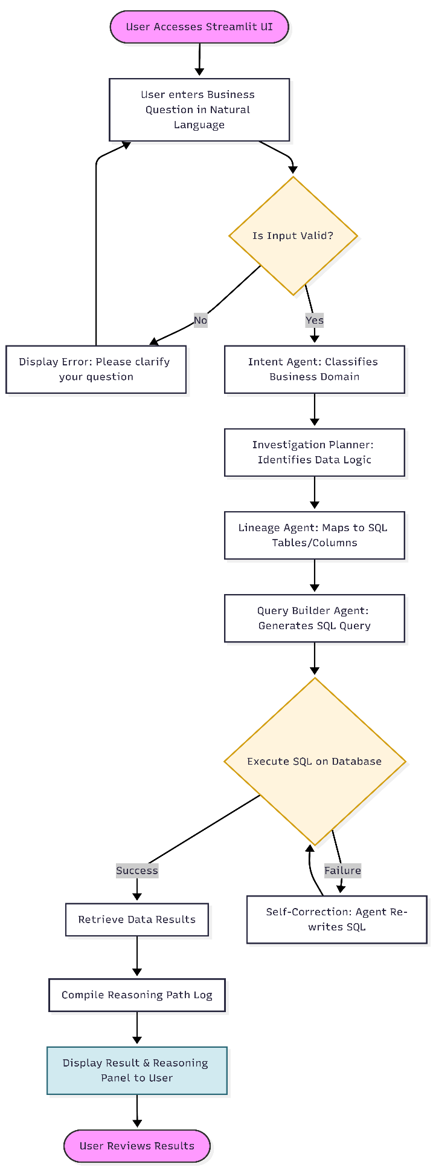
Scrappy Market
User Flow Diagram.
1. Legend.
- Ovals (Pink): Represent the Start and End points of the user journey.
- Rectangles (Blue/Gray): Represent automated processes or specific AI Agents (Intent, Planner, etc.).
- Diamonds (Yellow): Represent decision points or validation logic (e.g., SQL execution success/failure).
- Blue Boxes: Represent the final output visible to the end-user.

2. Step-by-Step Functional Description.
- Step 1: Intake: The user submits a natural-language query via the Streamlit interface.
- Step 2: Validation & Intent: The system validates the input and the Intent Agent categorizes the business domain.
- Step 3: Multi-Agent Planning: The Planner and Lineage agents collaborate to map the request to the specific database schema.
- Step 4: SQL Generation: The Query Builder Agent translates the plan into a structured SQL statement.
- Step 5: Execution & Self-Correction: The system runs the query. If an error is detected, a feedback loop allows the agent to self-correct the code.
- Step 6: Transparency: The final result is presented alongside a Reasoning Path, showing the user exactly how the agents reached the conclusion.

Mermaid code.
graph TD
%% Start of User Session
Start([User Accesses Streamlit UI]) --> Input[User enters Business Question in Natural Language]
Input --> Validate{Is Input Valid?}

%% Input Validation
Validate -- No --> Error[Display Error: Please clarify your question]
Error --> Input
Validate -- Yes --> IntentAgent[Intent Agent: Classifies Business Domain]

%% Multi-Agent Orchestration
IntentAgent --> Planner[Investigation Planner: Identifies Data Logic]
Planner --> ContextAgent[Lineage Agent: Maps to SQL Tables/Columns]
ContextAgent --> QueryAgent[Query Builder Agent: Generates SQL Query]

%% SQL Execution & Error Handling
QueryAgent --> Execution{Execute SQL on Database}
Execution -- Success --> DataReady[Retrieve Data Results]
Execution -- Failure --> Feedback[Self-Correction: Agent Re-writes SQL]
Feedback --> Execution

%% Final Output
DataReady --> Reasoning[Compile Reasoning Path Log]
Reasoning --> FinalUI[Display Result & Reasoning Panel to User]
FinalUI --> End([User Reviews Results])

%% Visual Styling
style Start fill:#f9f,stroke:#333,stroke-width:2px
style End fill:#f9f,stroke:#333,stroke-width:2px
style Validate fill:#fff4dd,stroke:#d4a017,stroke-width:2px
style Execution fill:#fff4dd,stroke:#d4a017,stroke-width:2px
style FinalUI fill:#d1eaf0,stroke:#2b6777,stroke-width:2px

